pf lab assignment #9

Mohammad Yehya Hayati , 21K-3309

Table of Contents

**Question #1** 2

**Question #2** 3

**Question #3** 5

**Question #4** 6

**Question #5a** 8

**Question #5b** 9

**Question #6** 10

**Question #7** 11

**Question #8** 12

**Question #9** 14

# **Question #1**

#include <stdio.h>

#include <string.h>

int main()

{

char fname[100],lname[100];

printf("Enter first name: ");

gets(fname);

printf("Enter last name: ");

gets(lname);

strcat(fname," ");

strcat(fname,lname);

printf("Your full name backwards is %s",strrev(fname));

}

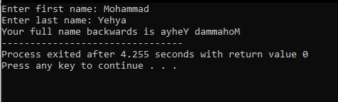

# **Question #2**

#include <stdio.h>

#include <string.h>

void printcaps(int a[1000]);

void printlows(int a[1000]);

int main()

{

int freq[1000] = {0},i;

char name[100],course1[100],course2[100];

printf("Enter your name: ");

gets(name);

for (i = 0 ; i < strlen(name) ; i++)

{

freq[name[i]]++;

}

printf("Enter your first course: ");

gets(course1);

for (i = 0 ; i < strlen(course1) ; i++)

{

freq[course1[i]]++;

}

printf("Enter your second course: ");

gets(course2);

for (i = 0 ; i < strlen(course2) ; i++)

{

freq[course2[i]]++;

}

printcaps(freq);

printlows(freq);

}

void printcaps(int a[1000])

{

int j;

for (j = 65 ; j < 91 ; j++)

{

if (a[j] != 0)

{

printf("The character %c occured %d times\n",j,a[j]);

}

}

}

void printlows(int a[1000])

{

int j;

for (j = 97 ; j < 123 ; j++)

{

if (a[j] != 0)

{

printf("The character %c occured %d times\n",j,a[j]);

}

}

}

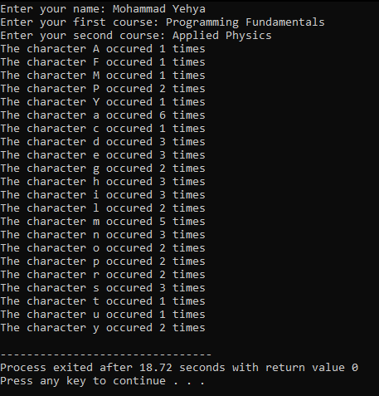

# **Question #3**

#include <stdio.h>

#include <string.h>

int main()

{

char choice1[100],choice2[100];

printf("Enter the first string: ");

gets(choice1);

printf("Enter the second string: ");

gets(choice2);

if (strcmp(choice1,choice2) < 0)

{

printf("The second string is greater.");

}

else if (strcmp(choice1,choice2) > 0)

{

printf("The first string is greater.");

}

else

{

printf("They are both equal.");

}

}

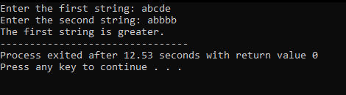

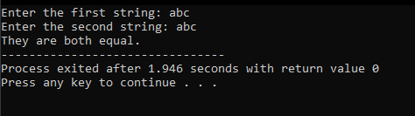

# **Question #4**

#include <stdio.h>

void Salesflow(int _marks , int _exp);

int main()

{

int marks,exp;

printf("Enter marks: ");

scanf("%d",&marks);

printf("Enter experience: ");

scanf("%d",&exp);

Salesflow(marks,exp);

}

void Salesflow(int _marks , int _exp)

{

if (_marks == 70 && _exp >= 2)

{

printf("Assigned Position: Associate Developer");

}

else if (_marks == 60 && _exp >= 1)

{

printf("Assigned Position: Assistant Developer");

}

else if (_marks == 50)

{

printf("Assigned Postion: Trainee Engineer");

}

}

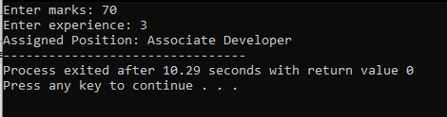

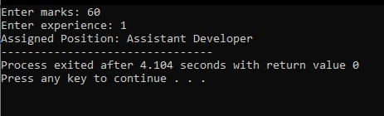

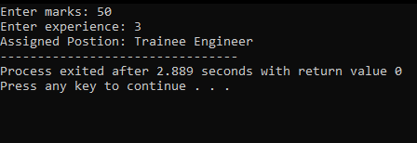

# **Question #5a**

#include <stdio.h>

void leapyear(int _year);

int main()

{

int year;

printf("Enter a year: ");

scanf("%d",&year);

leapyear(year);

}

void leapyear(int _year)

{

if (_year % 400 == 0)

{

printf("It is a leap year!");

}

else if (_year % 100 == 0)

{

printf("It is not a leap year!");

}

else if (_year % 4 == 0)

{

printf("It is a leap year!");

}

else

{

printf("It is not a leap year!");

}

}

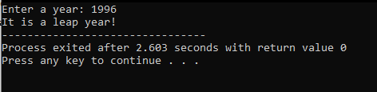

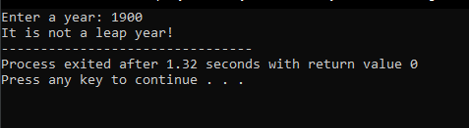

# **Question #5b**

#include <stdio.h>

int toQualityPoints(int _avg);

int main()

{

int avg;

printf("Enter your average: ");

scanf("%d",&avg);

printf("%d",toQualityPoints(avg));

}

int toQualityPoints(int _avg)

{

switch(_avg)

{

case 90 ... 100:

return 4;

break;

case 80 ... 89:

return 3;

break;

case 70 ... 79:

return 2;

break;

case 60 ... 69:

return 1;

break;

case 0 ... 59:

return 0;

break;

default:

return -1;

break;

}

}

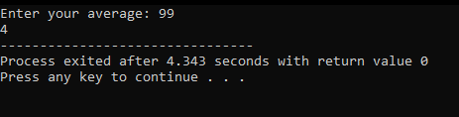

# **Question #6**

#include <stdio.h>

void getData();

float VolumeCalu(float a,float h);

int main()

{

getData();

}

void getData()

{

float a,h;

printf("Enter height: ");

scanf("%f",&h);

printf("Enter base area: ");

scanf("%f",&a);

printf("The Volume is %.2f",VolumeCalu(a,h));

}

float VolumeCalu(float a,float h)

{

return ((a*a)*(1.0/3.0)*h);

}

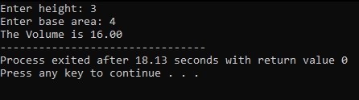

# **Question #7**

#include <stdio.h>

int trace(int _matrix[100][100],int _n);

int main()

{

int matrix[100][100];

int i,j,n;

printf("Enter the number and rows of a matrix: ");

scanf("%d",&n);

for (i = 0 ; i < n ; i++)

{

for (j = 0 ; j < n ; j++)

{

printf("Enter the value of a%d%d : ",i+1,j+1);

scanf("%d",&matrix[i][j]);

}

}

printf("The trace is : %d",trace(matrix,n));

}

int trace(int _matrix[100][100],int _n)

{

int sum = 0;

for (int i = 0 ; i < _n ; i++)

{

sum += _matrix[i][i];

}

return sum;

}

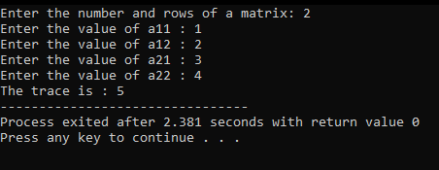

# **Question #8**

#include <stdio.h>

void populatearray(int arr[100][100],int n);

void addarrays(int arr1[100][100],int arr2[100][100],int n);

void subarrays(int arr1[100][100],int arr2[100][100],int n);

void multarrays(int arr1[100][100],int arr2[100][100],int result[100][100],int n);

int main()

{

int mat1[100][100],mat2[100][100],result[100][100];

int n;

printf("Enter how many rows and columns: ");

scanf("%d",&n);

populatearray(mat1,n);

populatearray(mat2,n);

addarrays(mat1,mat2,n);

subarrays(mat1,mat2,n);

multarrays(mat1,mat2,result,n);

}

void populatearray(int arr[100][100],int n)

{

int i,j;

for (i = 0 ; i < n ; i++)

{

for (j = 0 ; j < n ; j++)

{

printf("Enter number at a%d%d postion: ",i+1,j+1);

scanf("%d",&arr[i][j]);

}

}

printf("\n");

}

void addarrays(int arr1[100][100],int arr2[100][100],int n)

{

int i,j;

for (i = 0 ; i < n ; i++)

{

for (j = 0 ; j < n ; j++)

{

printf("%d\t",arr1[i][j] + arr2[i][j]);

}

printf("\n");

}

printf("\n");

}

void subarrays(int arr1[100][100],int arr2[100][100],int n)

{

int i,j;

for (i = 0 ; i < n ; i++)

{

for (j = 0 ; j < n ; j++)

{

printf("%d\t",arr1[i][j] - arr2[i][j]);

}

printf("\n");

}

printf("\n");

}

void multarrays(int arr1[100][100],int arr2[100][100],int result[100][100],int n)

{

int i,j,k;

for (i = 0; i < n; ++i)

{

for (j = 0; j < n; ++j)

{

for (k = 0; k < n; ++k)

{

result[i][j] += arr1[i][k] * arr2[k][j];

}

}

}

for (i = 0 ; i < n ; i++)

{

for (j = 0 ; j < n ; j++)

{

printf("%d\t",result[i][j]);

}

printf("\n");

}

}

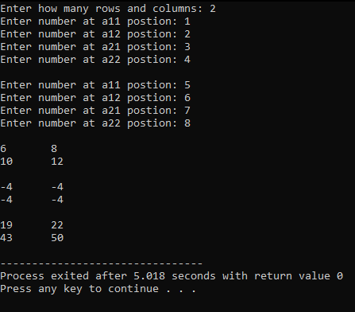

# **Question #9**

#include <stdio.h>

int main()

{

int i,j,mat[5][9] = {0};

for (i = 0 ; i < 5 ; i++)

{

printf("Enter Student ID: ");

scanf("%d",&mat[i][0]);

for (j = 1 ; j < 6 ; j++)

{

printf("Enter marks of course %d: ",j);

scanf("%d",&mat[i][j]);

mat[i][7] += mat[i][j];

}

printf("Enter total marks: ");

scanf("%d",&mat[i][6]);

mat[i][8] = mat[i][7]*100/mat[i][6];

}

for (i = 0 ; i < 5 ; i++)

{

for (j = 0 ; j < 9 ; j++)

{

printf("%d\t",mat[i][j]);

}

printf("\n");

}

}

